AS1 – Unit Testing **Blake McLeod (2102771708)**

Test Plan –

1. Write code for all the temperature conversions.
2. Establish they are logical and grouped in a logical order.
3. Test they work as expected and fix any bugs that may arise.
4. Once the tests have passed.
5. Copy the code 3 times to test for:
   * Boiling point at sea level
   * Freezing at sea level
   * Where F and C are equal
   * Absolute zero

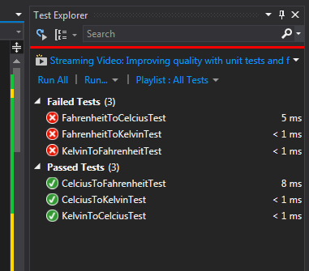

Screenshot 1 – Initial setup of test methods, testing all units at 1.0f, fails are a result of recurring decimal numbers that are not truncated.

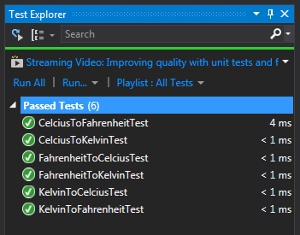

Screenshot 2 – Completed the calculations and logic for successfully converting the temperatures and truncating the result to 2 decimal places without rounding the values.

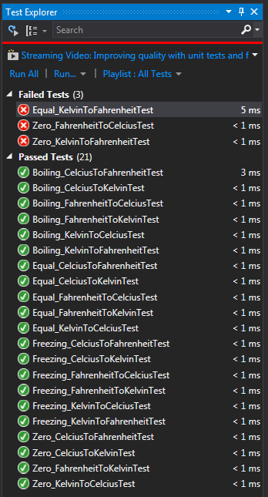

Screenshot 3 –I had some problems with the results coming back as truncated and the actual result from the calculation. After debugging I found the actual result coming back had a significant amount of decimal places for some tests. I determined the exact result and adjusted the test accordingly to result in a Pass.

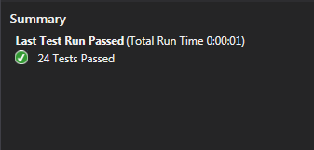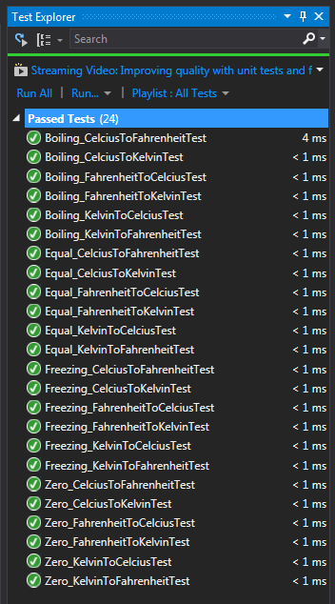Screenshot 4 – All tests have passed and the assignment is complete! ☺